
NATIONAL TEXTILE
UNIVERSITY
DEPARTMENT OF COMPUTER SCIENCE
Subject
Operating System
SUBMITTED BY:
Fatima Waseem: 23-NTU-CS1155
SECTION SE: 5th (A)
SUBMITTED TO:
Sir Nasir

Docker Lab 2

Docker File:

FROM node:lts-alpine3.23

COPY index.js .
COPY package.json .
COPY public ./public

#install packages
RUN npm i

#starting command
CMD ["node", "index.js"]

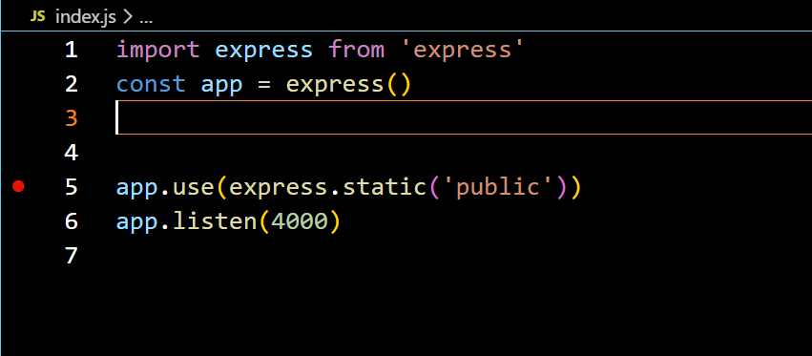
Index.js:

Browser Screenshot:
